LAB 2 cont.

13. Create a folder called myteam in your home directory and change its permissions to read only for the owner.
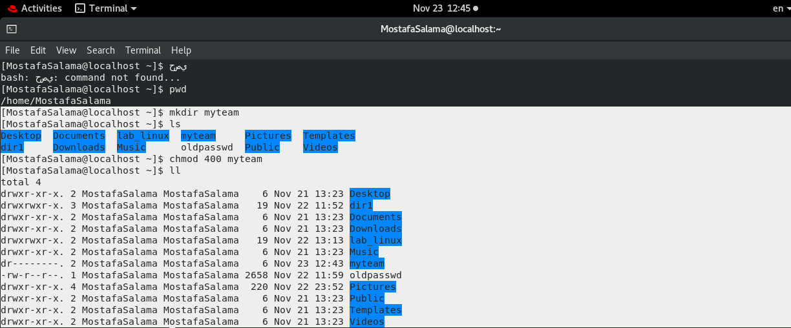

14. Log out and log in by another user
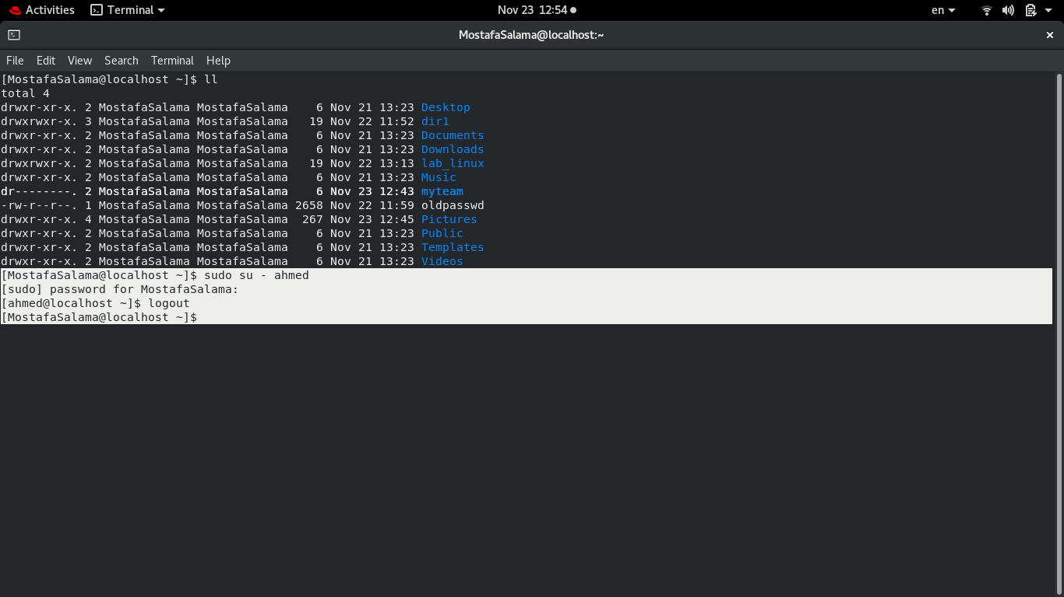
15. Try to access (by cd command) the folder (myteam).
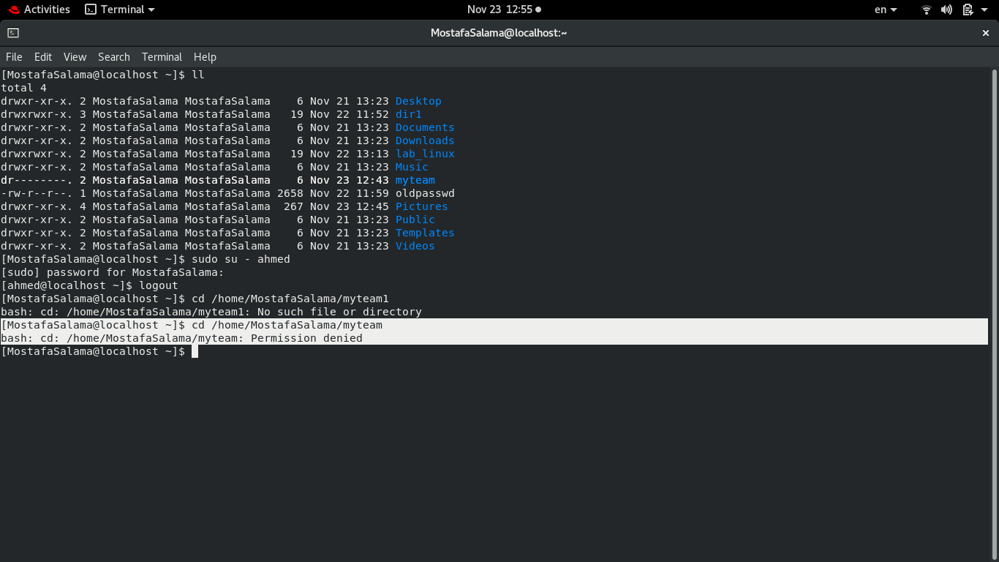
16. Using the command Line
a- Change the permissions of oldpasswd file to give owner read and write
permissions and for group write and execute and execute only for the others
(using chmod in 2 different ways)
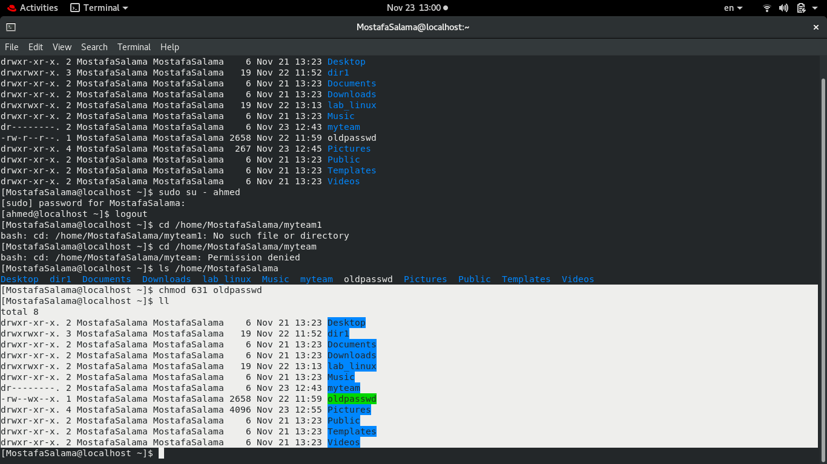
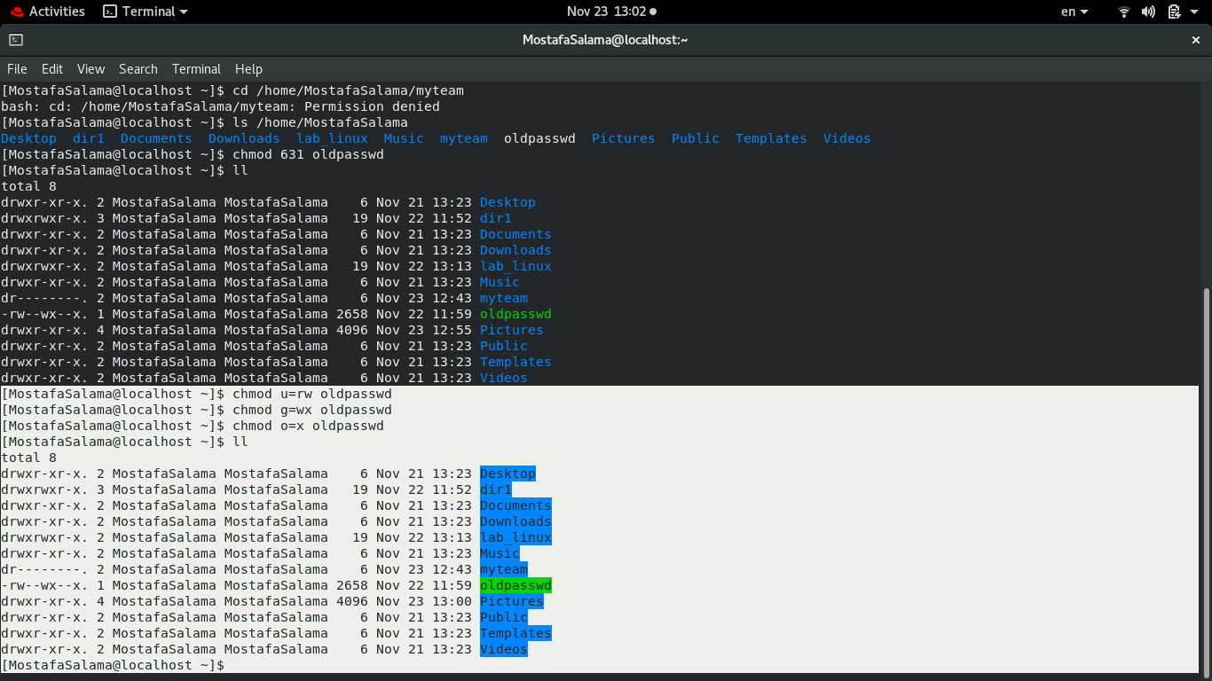
b- Change your default permissions to be as above.
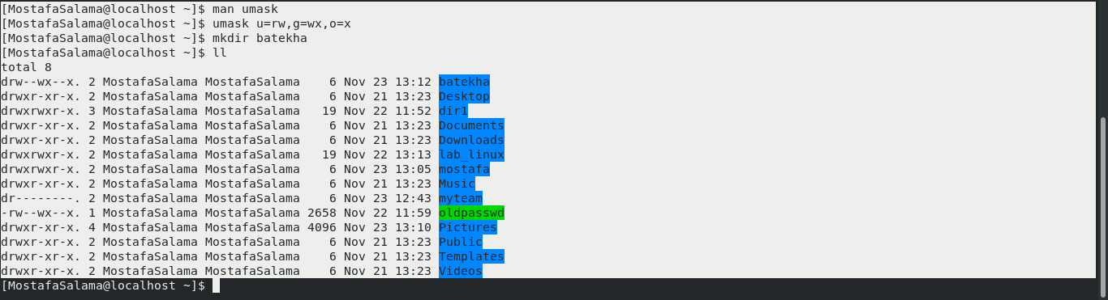
c- What is the maximum permission a file can have, by default when it is just Created? And what is that for directory.
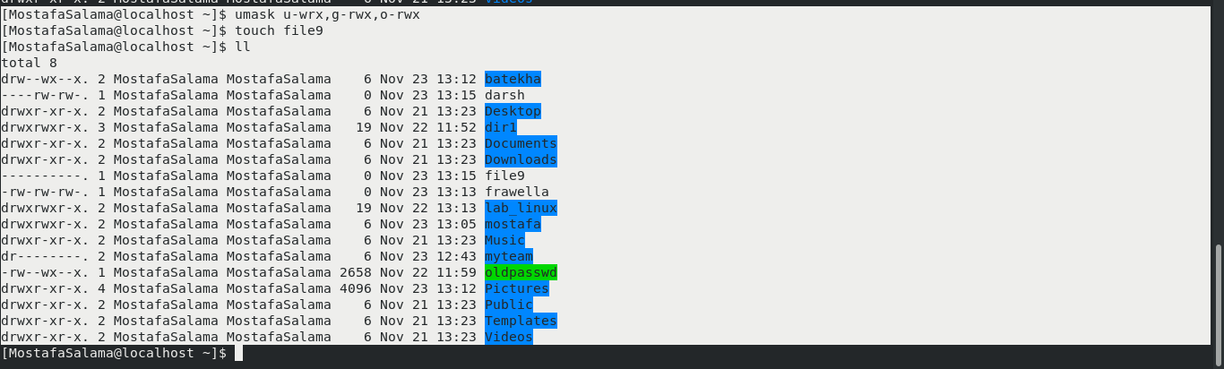
d- Change your default permissions to be no permission to everyone then create directory and a file to verify.
17. What are the minimum permission needed for:
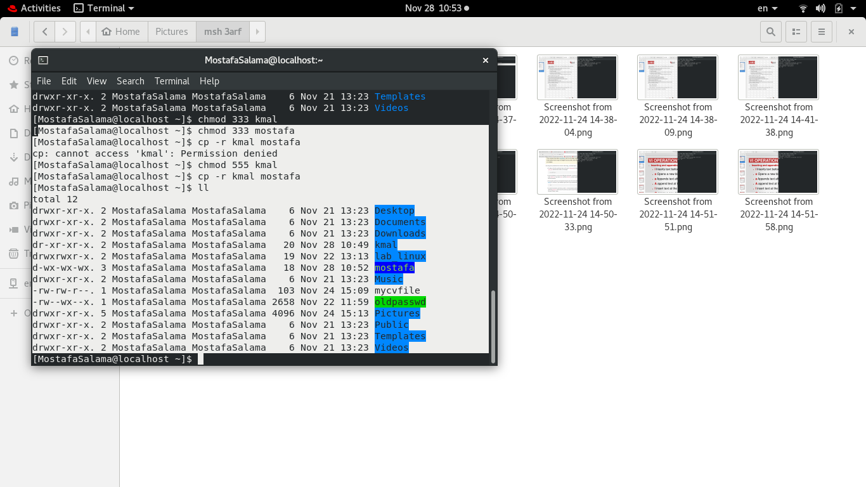
a-Copy a directory (permission for source directory and permissions for target parent directory)

b- Copy a file (permission for source file and and permission for target parent directory)
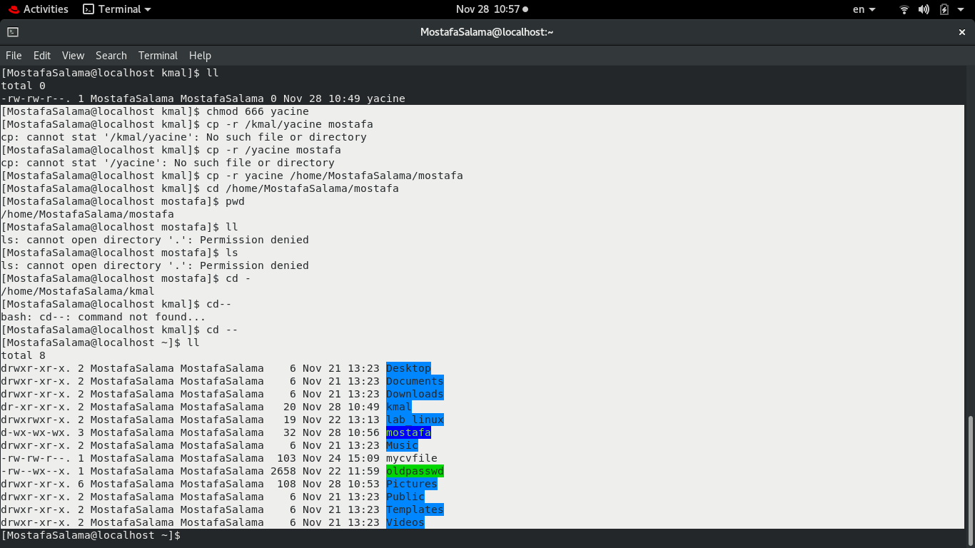
c- Delete a file
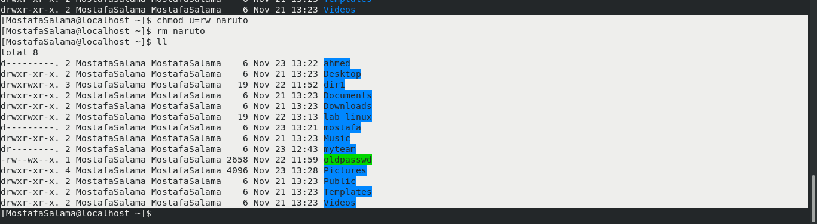
d- Change to a directory
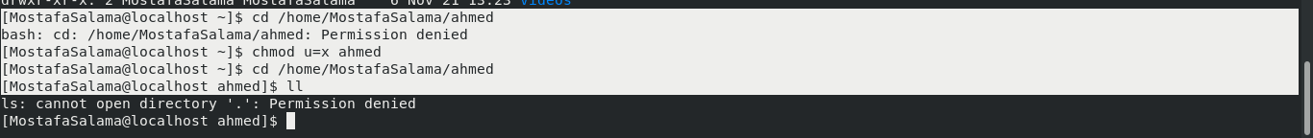
e- List a directory content (ls command)
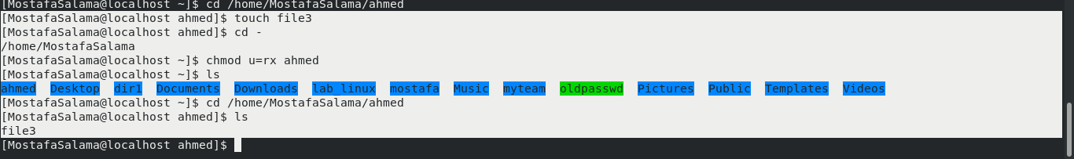

f- View a file content (more/cat command)
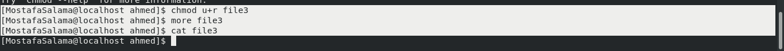
g- Modify a file content
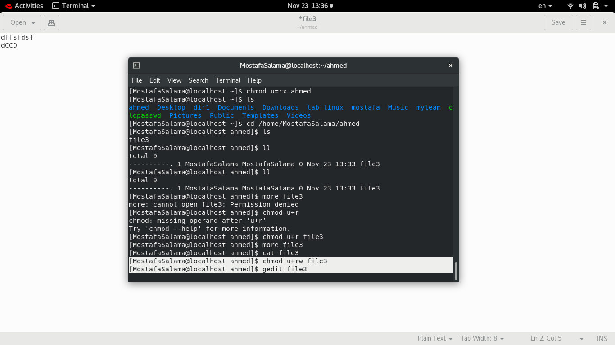
18. Create a file with permission 444. Try to edit in it and to remove it? Note what happened.
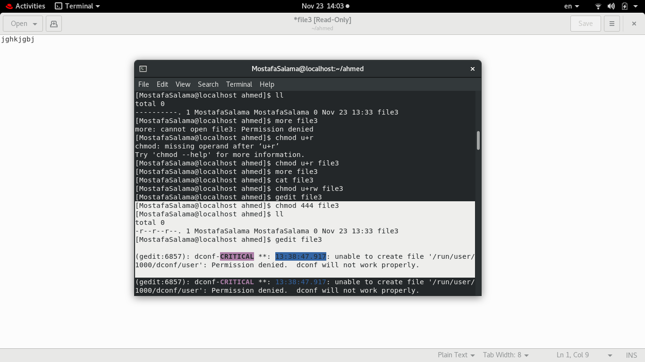
19. What is the difference between the “x” permission for a file and for a directory?
Execute permission on files means the right to execute them, if they are programs. For directories, execute permission allows you to enter the directory and to access any of its files

